Rest and Soap Web Service in Java

Web Service: Service delivered over web.

Jar file: A java archive file is a file format/ archiving tool which contains all the components of an executable Java application. All the predefined libraries are available in this format.

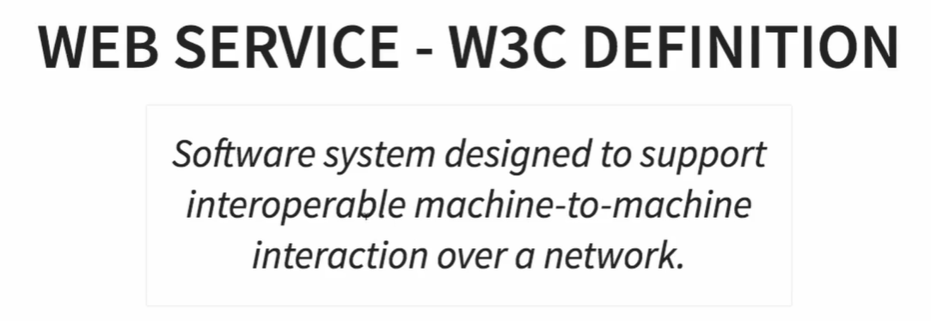

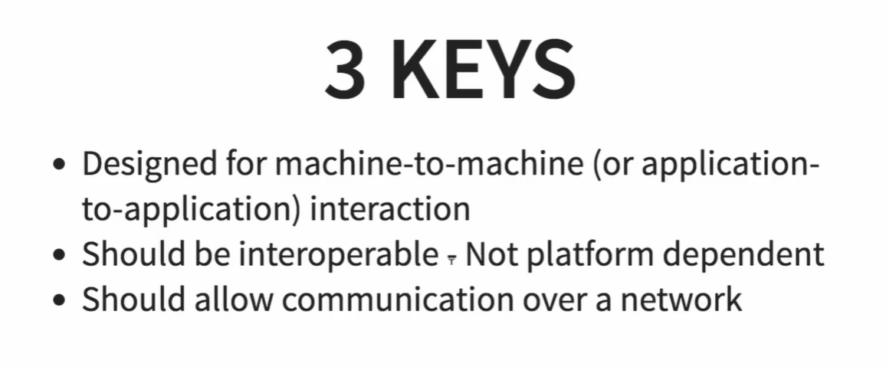

**SOAP Structure**

